

Project

on

**Corruption in Bangladesh**

**Submitted by:**

Name: Motaleb Sarker

Roll: 01/51/03

Batch: 51

**Submission Date:** 14/12/2024

**Table Of Contents**

| **Description** | **Page** |
| --- | --- |
| Abstract | 1 |
| Introduction | 1-2 |
| Causes of corruption | 3-5 |
| Impact of corruption | 6-9 |
| Current state of corruption in Bangladesh | 9-12 |
| Types of Corruption | 12 |
| Measuring corruption | 12-14 |
| Recent major corruption in Bangladesh | 14-19 |
| Combating corruption : my perspective | 20 |
| Conclusion | 21 |
| References | 22 |
|  |  |

**Corruption In Bangladesh**

**Abstract :** Corruption, commonly referred to as the abuse of entrusted power for private

gain, is a multi-sector phenomenon, present both in the public and private sector, and in the political arena. While corruption can take the form of petty crime or complex high-level corruption, it can also hide behind favouritism and nepotism, conflicts of interest and revolving doors – where business meets politics.

In this article, we will delve deeply into the topic of corruption. We will explore the true nature of corruption from various well-known sources and examine how it is structured. Our goal is to uncover the root causes of corruption. We will provide an in-depth analysis of corruption in Bangladesh, including its current state, the types of corruption that occur, and the levels at which they exist. We will also gain a comprehensive understanding of the impacts of corruption and discuss the measures that can be taken to combat it. Additionally, we will address the challenges a country may encounter in fighting corruption and compare Bangladesh’s situation with other nations that are relatively corruption-free in contemporary times. Finally, we will offer several recommendations to help us in the fight against corruption.

**Introduction to Corruption**: Corruption is harmful to society. It constitutes a threat to security as it enables and drives organised crime, terrorism, and other forms of crimes, including money-laundering or drug trafficking. Corruption deepens inequalities, erodes citizens’ trust in public institutions, undermines good governance and social justice, and constitutes a serious threat to the rule of law, democracy, and fundamental rights. Corruption also has a negative impact on prosperity and economic growth by creating business uncertainty, lowering investment levels, hampering fair competition and reducing public finances. It also adversely affects government objectives that focus on improving income disparity and environmental protection.

This Brief addresses how understandings of corruption have changed over

time, particularly focusing on the practical implications of definitions for how we address corruption. There is no universally accepted definition of corruption, but it is often

defined in terms of individual actions that “abuse entrusted power for private gain.” Other

ways of defining corruption reflect broader issues like who exercises power over natural resources, who is excluded, and how informal powers compete and interact with formal institutions. Corruption has been defined by various authors, institutions  and scholars in different ways, reflecting the complexity and multifaceted nature of the concept. Here are some world wide famous defenition of corruption.

* Transparency International: Transparency International defines corruption as “the abuse of entrusted power for private gain.” This definition applies to both public and private sectors, covering a wide range of corrupt activities, from petty corruption in public services to grand corruption at the highest levels of government.
* World Bank: As mentioned earlier, the World Bank defines corruption as “the abuse of public office for private gain.” This includes actions like bribery, fraud, embezzlement, and other forms of misconduct where public officials misuse their position for personal benefit.
* United Nations: The United Nations Convention against Corruption (UNCAC) does not offer a single, concise definition of corruption, but it describes it broadly as any “act of soliciting, offering, giving, or accepting of an inducement or reward that may improperly influence the actions of a person.”
* Organisation for Economic Co-operation and Development (OECD): The OECD focuses on corruption in international business transactions, defining it as “the active or passive misuse of the powers of public officials (appointed or elected) for private financial or other benefits.”
* International Monetary Fund (IMF): The IMF refers to corruption as “the abuse of public authority or trust for private benefit.” This definition aligns with its focus on how corruption impacts economic performance and governance.
* Joseph Nye : He defines corruption as "behavior which deviates from the formal duties of a public role because of private-regarding (personal, close family, private clique) wealth or status gains; or violates rules against the exercise of certain types of private-regarding influence."
* Robert Klitgaard: Klitgaard provides a formulaic definition: "Corruption equals monopoly power plus discretion minus accountability" (C = M + D - A). This suggests that corruption occurs when an individual or organization has unchecked power and uses it without accountability.
* Samuel Huntington: Huntington described corruption as the "behavior of public officials which deviates from accepted norms in order to serve private ends."
* Vito Tanzi: He defines corruption as "the intentional non-compliance with the arm’s-length principle aimed at deriving some advantage for oneself or for related individuals from this behavior."
* Susan Rose-Ackerman: Rose-Ackerman views corruption as "a symptom that something has gone wrong in the management of the state. Institutions designed to govern the interrelationships between the citizen and the state are used instead for personal enrichment and the provision of benefits to the corrupt.

By analysing the defenitions given by authors ,international organizations and scholars we can say that ‘ Corruption refers to misusing public power for personal gain. It can be done by an elected politician, civil servant, journalist, administrator of a school, or anyone in authority. Apart from public corruption, we also have private corruption between individuals and businesses. For instance, education, heritage, marriage, etc.’

**Causes of corruption**

Although corruption differs from country to country, it is possible to identify some of the key common driving forces that generate it. What is common to all countries, which are among the most corrupt, has been identified by Svensson ,all of them are developing countries or countries in transition,

* with rare exceptions, low-income countries,
* most countries have a closed economy,
* the influence of religion is visible (Protestant countries have far the lowest level of corruption),
* low media freedom and
* a relatively low level of education.

Regardless of the above, corruption cannot be assessed unambiguously, since there is never only one phenomenon that is responsible for the occurrence and the development of it; corruption always arises from an array of several, interrelated factors, which can differ considerably from one another. Among the most commonly mentioned factors that influence the development of corruption are: political and economic environment, professional ethics and legislation, as well as purely ethnological factors, such as customs, habits and traditions.

* **. Political and economic environment**

Corruption is strongly influenced by the political and economic environment. When a country's economy is heavily regulated, officials gain more power in decision-making, increasing the likelihood of corruption, as individuals may offer payments to bypass restrictions. Corruption flourishes where officials have discretionary power. Additionally, monetary policy plays a role; research by Goel and Nelson shows that countries with well-regulated financial sectors and fewer black markets experience less corruption. Greater political and economic freedom correlates with lower corruption levels. Inefficient public administration, ineffective regulations, and unclear permits further contribute to corruption by creating fertile ground for it to thrive.

1. The artificially created monopoly of power that enables civil servants to obtain bribes is based on their superior position and embedded in the system.
2. On the other hand, however, ineffective and unclear regulations cause inhibition and therefore encourage natural persons to pay bribes in order to speed up the bureaucratic procedure.

Low salaries of public officials are a significant factor in corruption, particularly in developing countries where tax revenues are insufficient to properly compensate them. Underpaid officials may resort to accepting bribes to improve their financial situation. However, corruption is also influenced by the poor state of public administration, where political loyalty often takes precedence over professional standards. Dissatisfaction with work also contributes to corruption, as shown by studies indicating that the private sector, with higher ethical standards, is less prone to corruption. While higher salaries may reduce corruption, they can also increase bribery demands, making salary just one of many contributing factors.

The economy often mirrors political influence and can reflect the rule of law. Bribery becomes a common tactic in job competition, and some view it as a necessary business expense or a standard practice. Corruption at higher political levels tends to permeate all levels of society, eroding trust in institutions. Johnston highlights that corruption can be mitigated when institutions balance openness and autonomy, allowing officials to be accessible yet independent from undue influence. When institutions lack this balance and officials exploit their power excessively, corruption is more likely to thrive.

* **. Professional ethics and legislation**

Corruption is exacerbated by a lack of professional ethics and inadequate laws for addressing it as a criminal offense. Ineffective sanctions for corruption encourage continued illegal activities and prompt others to participate. In transition countries, professional ethics and standards may change slowly or remain outdated, leading to a tolerance of "softer" corruption forms. Additionally, corruption thrives in environments with poor transparency, weak supervisory controls, and ambiguous legislation that allows for varied interpretations to benefit those who engage in bribery.

* **. Habits, customs, tradition and demography**

Corruption attitudes vary significantly across countries. In Europe, there is a stark contrast between the corruption-intolerant North and the more accepting South. Countries with democratic histories often have stricter anti-corruption measures compared to former socialist states where corruption was widespread. Cultural norms also play a role; in some regions, practices like gifting for services are seen as normal, while in others, they are viewed as corrupt. Informal social security systems, prevalent in less developed or Southern European countries, can foster nepotism and cronyism. Religious influences also impact corruption levels, with Protestantism historically linked to lower corruption, though this is not a definitive causal relationship. Research shows that perceptions of corruption are influenced by social status, education, and economic conditions, with economic instability often increasing the perceived prevalence of corruption.

Demographics significantly influence corruption, with patriarchal societies generally showing higher corruption levels. Studies, including those by the World Bank, indicate that women are less prone to corruption compared to men. Research across Europe, Africa, and Asia supports this view, suggesting that increased female representation in government and the labor market can reduce corruption. Women tend to be less corrupt, especially in cultures emphasizing male ambition and competitiveness. For example, the introduction of female police officers in Peru led to a notable reduction in bribery, highlighting the positive impact of gender diversity on corruption control.

**Impact of Corruption**

The effects of corruption are wide-ranging. Some of these effects are fairly obvious, while others require explanation. They include:

**Economic loss and inefficiency**

Corruption significantly hinders the achievement of the United Nations Sustainable Development Goals (SDGs). It weakens state capacities, undermining efforts to reduce poverty, hunger, and inequality while obstructing access to healthcare and education. Corruption particularly threatens SDG 16, which focuses on peace, justice, and strong institutions. It leads to unaccountable governance and diverts essential funds, worsening living standards. Tackling corruption is crucial to achieving sustainable development, as it directly impacts global efforts to improve living conditions and build transparent, effective institutions. Global anti-corruption measures must be strengthened to ensure progress toward the SDGs.

**Poverty and inequality**

Corruption is often a tool of the powerful, as seen in Nigeria's bribery scandal involving Shell, where over $1.1 billion was lost to corrupt officials, leaving more than 50% of the population in poverty. This case highlights how corrupt actors manipulate political and economic systems to divert wealth, depriving funds for education, healthcare, and poverty alleviation. As a result, corruption undermines political representation and economic efficiency, benefiting only those within corrupt networks while severely compromising social programs and the redistributive functions meant to help the broader population.

**Personal loss, intimidation and inconvenience**

Experiencing corruption is seldom a positive affair. Individuals may be forced to pay bribes to access medical care, obtain permits, retrieve packages, or receive phone services. In the judicial system, a judge might rule against a party not based on the case facts but because of a bribe, connections, or racial/ethnic ties. Police officers may beat, detain, or impose higher fines on those who refuse to pay bribes. Retirement funds can be lost to fraud or tied up in money laundering. While victims face personal loss, intimidation, and inconvenience, those involved in corrupt practices often gain personal benefits, a sense of superiority, and greater ease—at least until legal action is enforced.

**Public and private sector dysfunctionality**

The cumulative impact of individual acts of corruption is systemic dysfunction. Whether occurring in public or private sectors, corruption diminishes the quality of goods and services and makes their procurement more costly, time-consuming, and inequitable. When bribes successfully sway police, doctors, or civil servants, those who excel at extracting bribes advance unfairly, sidelining more honest peers and competitors. Additionally, corporations may lose motivation to improve services or products if they can gain advantages through political favors. State-owned enterprises often prioritize enriching officials over pursuing innovation and efficiency, leading to a loss of intrinsic motivation within organizations. Workers and managers become demoralized, and belief in the value of hard work and innovation erodes.

**Failures in infrastructure**

When a bridge in Genoa collapsed in August 2018, killing at least 39 people, initial investigations did not prominently consider corruption as a cause. However, it was later discovered that a Mafia-linked construction company used "weakened cement" in the bridge's construction. The construction industry is notorious for being a lucrative source for Mafia money laundering and corruption. Oversight and competition are often compromised in such industries. Similarly, a 2017 report by Mexicans Against Corruption and Impunity linked corruption to the collapse of over 40 buildings during the September 2017 Mexico City earthquake. Bribery, cronyism, and influence trading had led to violations of land-use and permit laws, resulting in unsafe buildings throughout the city.

**Rigged economic and political systems**

What is described as dysfunctional above is actually functional and profitable for corrupt actors. Whether termed political cronyism, crony capitalism, political party cartels, oligarchy, plutocracy, or kleptocracy, pervasive private and public corruption creates social systems that favor private interests. Citizens with strong ethical principles, or those without substantial funds, connections, or means of coercion, lose representation, influence, and power.

**Impunity and partial justice**

When corruption infiltrates the justice system, people can no longer rely on prosecutors and judges to uphold the law. The powerful might evade justice, while ordinary citizens, especially those without resources or influential connections, may face wrongful accusations, lack of due process, and unjust imprisonment. Resources on preventing corruption and enhancing judicial integrity can be found on the UNODC Global Judicial Integrity Network's website.

**Organized Crime and Terrorism**

Organized crime and terrorism exploit weaknesses in the justice system and political structures to further their agendas. Corruption facilitates these criminal activities by enabling money laundering, disguising illicit funding, and bribing officials, which can lead to increased violence, illegal drug trade, prostitution, sexual slavery, kidnapping, and intimidation. The relationship between corruption and organized crime is bidirectional. Organized crime often generates corruption, and conversely, weak or negligent states can foster environments ripe for organized crime. For a detailed exploration of this corruption-crime connection, refer to Module 11 of the E4J University Module Series on Anti-Corruption and Module 4 of the E4J University Module Series on Organized Crime.

**Diminished State Capacity**

Corruption severely hampers political effectiveness, undermining efforts to address social issues and threatening vested interests. Bribery, influence peddling, and state capture compromise political systems, rendering them ineffective. State incapacity may manifest through distracting issues, scandals, or political maneuvering designed to obstruct systemic reforms. Corruption undermines public service ethos and alters political culture, making genuine reforms almost impossible, as discussed by Della Porta and Vannucci (2005).

**Climate Change and Damage to Biodiversity**

Corruption disrupts climate change initiatives, undermines forest conservation, and fuels wildlife crimes. According to Transparency International and Naomi Klein's *This Changes Everything* (2014), state capture by powerful industries often blocks legislative efforts to combat climate change. Corruption's impact on the environment includes illegal timber harvesting and wildlife crime, as detailed in reports like *Rotten Fish* (UNODC, 2019) and *Authorized to Steal* (CIEL, 2019).

**Human Rights Violations**

Corrupt leaders often view civil liberties as impediments to consolidating power. The UN Office of the High Commissioner for Human Rights (OHCHR) identifies corruption as a significant barrier to upholding human rights. Corruption impedes the state's ability to address human rights abuses and socioeconomic rights, leading to violations and systemic failures.

**Corruption in an organisation can result in:**

* financial loss
* damage to employee morale
* damage to its reputation
* focus and resources being diverted away from delivering core business and services to the community
* increased scrutiny, oversight and regulation.

**Corrupt individuals may face:**

* disciplinary action
* losing their job
* criminal charges
* damage to relationships.

**Community impacts include:**

* wasted taxpayer funds
* loss of goods and services
* lower community confidence in public authorities
* disadvantage to honest businesses seeking to win government contracts

**Current state of Corruption in Bangladesh**

Bangladesh is an underdeveloped country in South Asia and the political situation of Bangladesh is not as stable as Pakistan and Sri Lanka, due to which the change of power has not achieved any permanent improvement in the country. Extortion, bribery, killing, disappearance, attack, theft, robbery are daily occurrences in various parts of the country, although corruption has decreased somewhat in recent times. Since independence, Bangladesh's level of corruption in corruption is given below.

**Corruption index of Bangladesh by Transparency International**

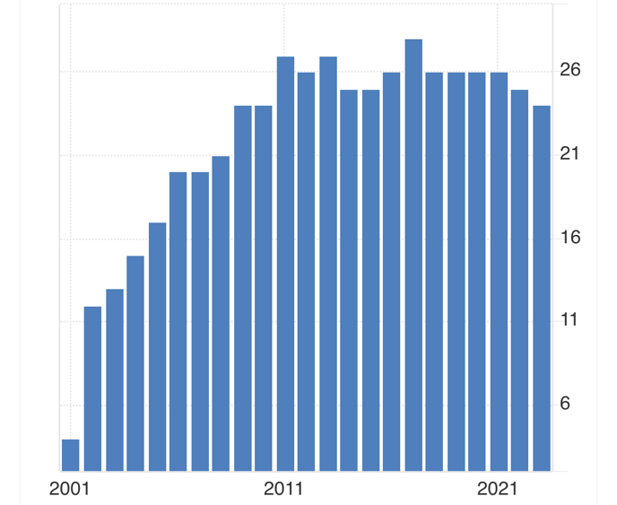

The chart shows the Corruption Index of Bangladesh from 2001 to 2021. The Corruption Perception Index (CPI) ranges from 0 to 100, where 0 represents a highly corrupt perception and 100 represents a very clean perception.

Starting in 2001, Bangladesh's corruption index was relatively low, below 10, indicating a high perception of corruption. Over the following decade, there is a noticeable rise, with the index reaching approximately 23 by 2010, suggesting a reduction in the perception of corruption.

From 2011 onwards, the index stabilized between 23 and 27, remaining fairly consistent over this period. The peak of the index appears to be around 26 in 2012 and 2013, after which the index shows some fluctuations but stays generally high. By 2021, the index drops slightly to around 23.

This consistent trend from 2010 to 2021 reflects a relatively moderate corruption perception. The rise in the corruption index during the earlier years suggests that Bangladesh made some progress in combating corruption, though it plateaued afterward and didn’t achieve significant further improvements.

**Types of Corruption in Bangladesh**

It has been mentioned in the beginning of this article that corruption happens in Bangladesh for some reason, the education rate of Bangladesh is very low and the people of this country are generally very less aware, because of this, every sector, whether it is health, education, public, private, or even at the very field level, every institution is associated with corruption. . Following the field research we have found the pillars of corruption in Bangladesh and the sectors in which it is organized are detailed below.

* 1. **Bureaucratic Corruption**: A government or a country is run by a large amount of government manpower and what we usually call bureaucracy in Bangladesh bureaucracy is very large and bureaucracy plays a very large role in determining any policy in Bangladesh and every sector of the bureaucracy of Bangladesh and the government of Bangladesh. Corrupted in some way.

If the common people go to any government office to get any government service, then the responsible bureaucrats demand bribe from them and they do not perform any kind of work without bribe. A government job or a person appoints in his place a person of his choice or a person who has paid him some bribe. Currently, bribery, favoritism, and nepotism are the biggest problems in bureaucracy.

**2.Political Corruption**: The corruptions that are organized in the politics of Bangladesh are usually the biggest type of corruption. Usually those who come to power politically come to power through corruption and buy votes from many people with money and even in voting there is corruption in almost 90 percent places. Those who are in political power exercise their power in various dishonest ways and if they commit any kind of corruption and that corruption is proved in court then they get away with their power without any punishment. Then they get money by dishonest means from the various funds that are given for the welfare of the people and the budgets that are taken for the welfare of the people. Bangladesh also has many records of murdering, missing or imprisoning a person for any political punishment under various circumstances.

**3.Judicial Corruption:** Corruption in the judiciary is very big in all the sectors that are rich in Bangladesh. All the people who are involved in the judicial sector of Bangladesh may want to implement the agenda of a particular political party or they have reached that place through dishonest means. People who are involved in justice in Bangladesh cannot do justice in maximum cases because they have different political issues and they are not able to apply the justice system in many cases by threatening them and in many cases many people are killed by misjudgment. Bangladesh has a long record of being held in jail for a long time and releasing many without reason through wrongdoing.

**4.Police Corruption** : The state uses its police force to maintain the internal law and order of the country and to maintain the peace and order of the country, but the police sector in Bangladesh is particularly corrupt. The police officers here belong to a particular political party and Appointments are made by and through those in power. Police are usually engaged to serve the people but instead of serving the people they act like sucking their blood.

**5.Corruption in Education**: One of the means of corruption in Bangladesh is education. There are many types of corruption in education, such as hiring teachers with money, selling question papers with money, increasing numbers with money, selling grades with money, giving various opportunities and privileges for money and owning them. We are lagging behind due to giving higher marks to preferred students etc and corruption in this field of education.

**6.Health Sector Corruption**: There are many types of corruption in the health sector of Bangladesh and even though there is very little allocation in the health sector of Bangladesh, still the people do not get the services they should get in the upazila and district level and village level hospitals. The number of doctors is very few and those doctors who are there do not perform their duties properly and wherever they are supposed to serve patients free of cost they charge them service charges and instead of serving patients they refer them to departmental hospitals or big hospitals and The biggest problem is that without thinking and considering the patient's health, they sell the drugs of any pharmaceutical company to give them benefits from the company they have taken pleasure from and this is the biggest corruption in the field of medicine and health, including wrong treatment. Not coming to the office is a daily occurrence.

**MEASURING CORRUPTION :** The measurement of corruption is a longstanding challenge for both academics and the policy community, due to the absence of unanimously agreed-upon definitions and the widespread belief that, due to its informal and hidden nature, corruption is an unobservable phenomenon. In the mid-1990s, however, the idea that corruption was un-measurable started to lose traction among academics and practitioners, and the debate turned from whether corruption can be measured into how corruption can be measured.

Despite the growing academic consensus regarding the possibility of developing meaningful and valid corruption measurements, the field still faces a number of challenges:

* Corruption is an umbrella term, encompassing a great variety of legal and illegal behaviours which can rarely be measured directly by a single indicator;
* Some of the most famous existing measurements, such as the Corruption Perceptions Index (CPI) and the Worldwide Governance Indicators stand accused of being conceptually weak, difficult to disaggregate, based on perceptions rather than experience, problematic to compare, and insensitive to change.

To address these challenges, the current trend in corruption measurement is moving away from aggregated indices towards more specialised measurements and judiciously-selected proxy indicators. It has also become clear that, given the complexity of the phenomenon of corruption, different types of measurement are necessary and that the quest for the best anti-corruption measurement is context-dependent. While the CPI, for example, is unlikely to help us evaluate the effects of specific policies in a specific country, an indicator suited for these needs is unlikely to allow for comparison across a large set of countries.

**The Crucial Role of Citizen Participation in Combating Corruption** :Citizen participation is fundamental in the fight against corruption, empowering individuals to influence public decisions and hold officials accountable. This engagement, which can be direct, such as voting and grassroots organizing, or indirect, driven by organizations like the Open Government Partnership, helps ensure that public decisions reflect the will of the people and incorporate local knowledge. In the context of anti-corruption, citizen involvement is particularly vital, as it includes reporting corrupt activities, supporting awareness campaigns, and refusing to participate in corrupt practices.

Technological advancements, such as smartphone apps and online platforms, have made it easier for citizens to report corruption. Platforms like India’s "I Paid a Bribe" or Europe’s Digiwhist increase public awareness and accountability by exposing everyday corruption. However, in countries with pervasive corruption, citizen apathy can develop, weakening the fight against corrupt practices. To counter this, initiatives like Transparency International’s Advocacy and Legal Advice Centre provide practical support to victims and witnesses of corruption.

Despite the risk of corruption becoming normalized, it is essential to empower citizens to recognize and challenge it. Unchecked corruption leads to deep inequalities, dishonesty, and societal instability. Effective citizen participation remains a key strategy in curbing corruption and fostering transparency.

**Recent Major Corruptions in Bangladesh**

**:** Despite being a democratic country, Bangladesh has been under virtual autocracy for the last 15 years under a government which has resorted to various forms of corruption during its rule and since corruption has spread in every sector but there are some areas where corruption has reached its peak and which Shocked the eyes of the whole world, we know that the Bangladeshi dictatorship of the past 15 years has ended through the student movement, and with the fall of this government, the various types and corruptions of the previous government are now being revealed. Now we will discuss the corruption.

**Corruption in education  ( Govt Exam Question Leaks ) :**

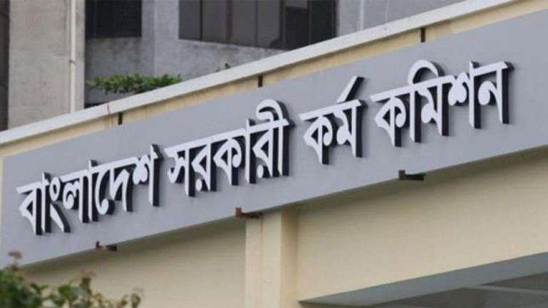

An investigative report by Channel-24 has alleged widespread corruption in the Bangladesh Public Service Commission (PSC), particularly regarding the leak of question papers for cadre and non-cadre recruitment exams. The report highlighted that around 30 previous recruitment exam questions, including the 46th BCS preliminary exam

were leaked, often with the involvement of high-ranking PSC officials. The problem extends beyond the BCS exam, affecting other key government recruitment processes. The revelations have deeply shocked the public, especially millions of young job seekers who toil tirelessly in the hope of securing government posts. Despite interviewing the PSC chairman, who expressed helplessness, the onus for the ongoing exam leak ultimately lies with the institution's leadership. More details are expected in the forthcoming investigation report.

**Selling positions in educational institutions**

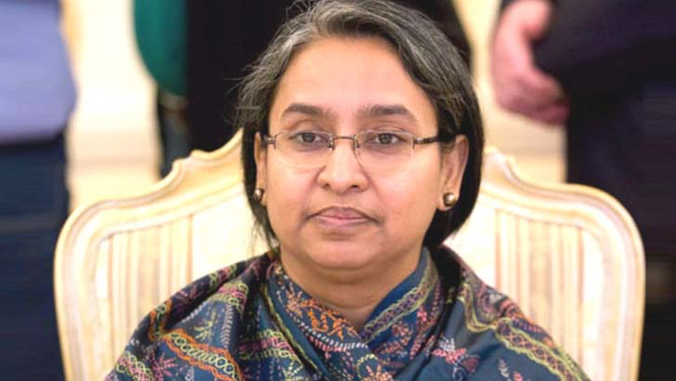



Dr. Dipu Moni, a former Bangladeshi minister under the Awami League government, is currently facing numerous allegations of corruption and abuse of power. As the Minister of Education, she is accused of taking bribes for appointments in educational institutions. It is reported that university vice-chancellor positions were sold for two crores, while college principal roles went for fifty lakhs. Her brother, JR Wadud Tipu, allegedly helped form a powerful syndicate within the education ministry that controlled transfers and appointments, with bribes ranging from two to twenty lakhs.

Dipu Moni and her brother were also implicated in illegal sand extraction activities in Chandpur, which reportedly generated substantial wealth. The Anti-Corruption Commission has since initiated an investigation into her finances.

In addition to her actions within the education sector, Dipu Moni is believed to have manipulated the boards of private universities, including North-South and Manarat International, to consolidate control. Despite being reassigned to the Ministry of Social Welfare after the 2024 elections, her involvement in corrupt practices continues to be widely discussed. Her actions have not only sparked public outrage but have also led to ongoing legal scrutiny into her financial dealings and influence within the government.

**Corruption in administration**



Commonly known about the corruption in the administrative field of Bangladesh, but after the end of long 15 to 16 years of autocracy, a lot of talk is coming out about the corruption of the administration, the armed forces are usually used to maintain the military and internal order of the state, but the previous ruler maintained his power. In order to keep all the important forces of the state like police, army and other important forces who are the heads and those who control those forces, the government has installed its own preferred people in place of the officers and those who are involved in various large scale corruption in the country. and for them to live a very luxurious life financially, the government allows them to do various forms of corruption in various fields so that they are financially self-sufficient and do not reach for power.

**Corruption in banking and financial sector**

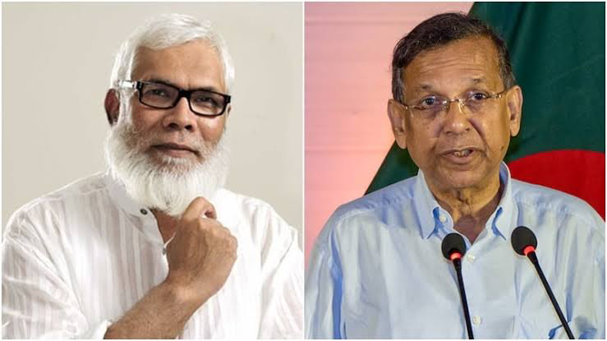



Salman F. Rahman, committed widespread financial corruption and fraud. He is a powerful businessman in Bangladesh. For years, he engaged in manipulating the stock market, securing fraudulent loans, and siphoning money from banks. He allegedly embezzled hundreds of thousands of crores of taka through schemes involving placement shares and stock market manipulation. Despite his illegal activities, Bangladesh Bank took no action against him. Rahman, with the help of former officials like Dr. M Khairul Hossain, Shibli Rubayat-Ul-Islam, and former Finance Minister A.H.M. Mustafa Kamal, obtained massive loans from public and private banks. He violated central bank regulations by securing excessive loans without adequate collateral and consistently rescheduled his debts without repaying them. These loans were taken in the names of his various companies, many of which were later exposed as benami or fake.

Rahman's involvement in the infamous stock market scams of 1996 and 2010 further devastated Bangladesh’s economy. Investigative reports repeatedly implicated him in market manipulation, causing massive losses to general investors. Additionally, his companies, such as Beximco Group, were involved in questionable mergers and bond issues, accumulating vast sums of money from the stock market. Despite legal battles, Rahman and his associates remained largely unscathed due to their political connections, allowing them to continue their fraudulent practices without facing significant consequences. His exploitation of the stock market and banking system remains a dark chapter in Bangladesh's economic history.

**Embezzlement of Funds from Major Projects**



A case involves the Rooppur Nuclear Power Plant. According to a report by Global Defense Corp, former Prime Minister Sheikh Hasina embezzled over $5 billion through her connection to the project. The report claims that Rosatom, the project’s implementing agency, facilitated this by funneling the funds through a Malaysian bank. The embezzlement was allegedly aided by her son, Sajeeb Wazed Joy, and niece, Tulip Siddiq. Tulip Siddiq reportedly played a key role in brokering the deal between Bangladesh and Russia, securing significant financial gains for herself and other family members. Allegations also suggest that a fraudulent company was created by Tulip, her mother Sheikh Rehana, and their relatives to launder money offshore, including the misappropriation of $900 million linked to the Destiny Group.

Another case involves land acquisition for the Padma Bridge project. The Anti-Corruption Commission (ACC) has filed a case against two individuals for embezzling BDT 45.7 million during the land acquisition process for the bridge. Mostafizur Rahman, a former surveyor at the land acquisition branch in Madaripur, and his accomplice Rubel Hawlader were accused of transferring the funds into multiple personal bank accounts between 2019 and 2020 using 18 different checks. Although Mostafizur denies the allegations, the ACC investigation found preliminary evidence of wrongdoing, leading to the legal case. Authorities are also pursuing additional individuals connected to the embezzlement.

**Malfeasance in Electoral Processes and  Misappropriation of Public Funds**

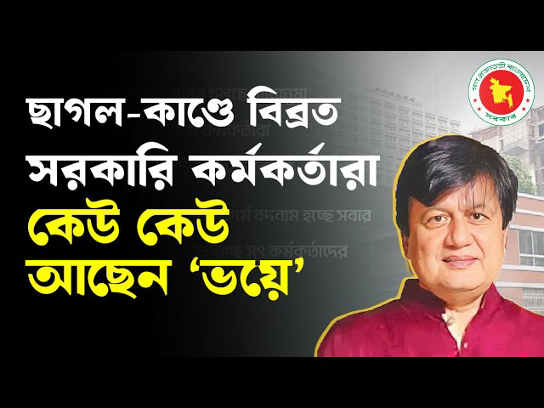

The recent viral incident involving Mushfiqur Rahman Ifat, who purchased a goat for 1.5 million BDT and a cow worth 7 million BDT before Eid-ul-Adha, has sparked widespread controversy in Bangladesh. Ifat's father, Dr. Matiur Rahman, an officer of the National Board of Revenue (NBR), came under scrutiny for his family's extravagant purchases, raising questions about the source of their wealth. In response, the Anti-Corruption Commission (ACC) began investigating the significant assets of Matiur Rahman and his relatives.

The investigation revealed an extensive portfolio of properties and financial investments owned by Matiur and his family, including resorts, bungalows, and large bank accounts. Despite holding a government position with a modest salary, Matiur has amassed significant wealth, raising concerns about corruption within the revenue sector. Consequently, he was removed from his position at the NBR and transferred to the Ministry of Finance's Internal Resources Division.

This scandal has brought discomfort to many government officials, as it has reinforced negative perceptions of public sector employees. While the government insists that only a few corrupt individuals are tarnishing the image of the entire sector, the case has reignited public discourse on corruption. The ACC is actively investigating Matiur's financial dealings, and his assets, including bank accounts and stock market investments, have been frozen. The investigation continues, with authorities committed to holding those involved in corruption accountable.

**Effective Strategies for Combatting Corruption: My Perspective**

Combatting corruption requires a multi-faceted approach targeting governance, law enforcement, and public awareness.Here are some steps which can be applied to combat corruption.i

1. **Strengthen Transparency**: Promote transparency in government processes, ensuring public access to information regarding budgets, contracts, and procurement.

2. **Enforce Anti-Corruption Laws:** Create and enforce stringent anti-corruption legislation that deters illegal activities through strict penalties.

3**. Establish Independent Anti-Corruption Bodies**: Set up independent agencies responsible for investigating and prosecuting corruption cases.

4. **Protect Whistleblowers**: Develop and enforce strong whistleblower protection laws to encourage reporting without fear of retribution.

5. **Enhance Judicial Independence**: Ensure the judiciary is independent from political influence to handle corruption cases impartially.

6. **Implement Regular Audits**: Conduct frequent audits of government finances and public institutions to detect and prevent mismanagement of funds.

7. **Promote Civic Education**: Educate the public about their rights and the dangers of corruption through widespread civic awareness campaigns.

8. **Encourage Public Participation**: Involve citizens in decision-making processes and policy formulation to promote accountability.

9**. Strengthen Law Enforcement**: Provide law enforcement with the necessary tools, training, and resources to effectively combat corruption.

10. **Promote Ethical Leadership**: Encourage political and business leaders to model integrity, setting a standard for ethical behavior.

11. **Reduce Bureaucracy**: Simplify administrative procedures to reduce opportunities for bribery and exploitation within public services.

12. **Digitize Government Services**: Use technology to automate government services, reducing the need for face-to-face interactions that could lead to corruption.

13. **Promote Media Freedom**: Support a free and independent press that can investigate and report on corruption without fear of censorship or persecution.

14. **Engage in International Cooperation**: Work with international organizations and other countries to combat cross-border corruption and money laundering.

15. **Establish Clear Conflict of Interest Rules**: Create regulations that prevent public officials from making decisions that benefit them personally..

**Conclusion** : In conclusion, corruption remains a significant challenge affecting various sectors worldwide. It undermines economic development, weakens institutions, and erodes public trust. However, with collective efforts from governments, institutions, and citizens, corruption can be tackled effectively. Measures such as increasing transparency, enforcing strict laws, fostering accountability, and promoting ethical leadership are vital in the fight against corruption. Public participation and awareness play a crucial role in sustaining these efforts. By working together, we can create a fairer, more just society, where corruption is minimized, and integrity becomes the cornerstone of governance.